LAB Logbook

Lab 1

Lab 2

Accuracy: “0.931”

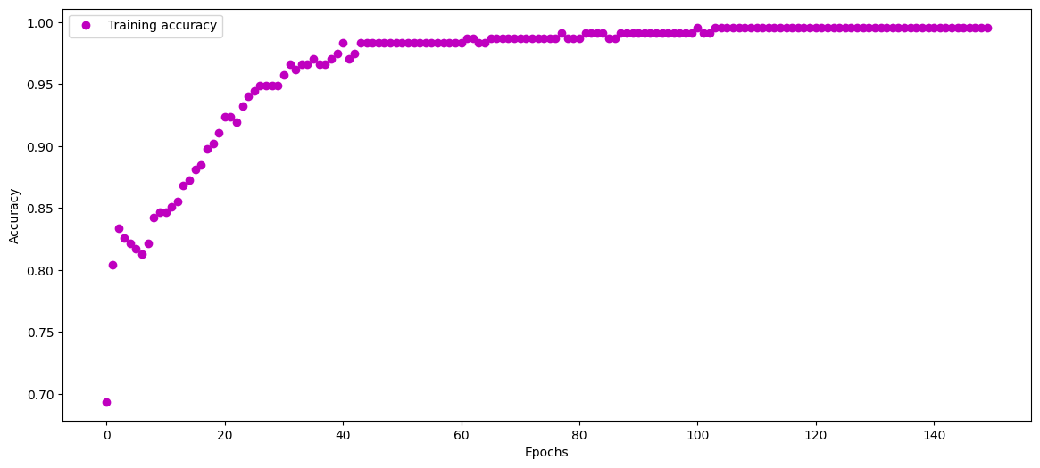

Lab 3

Accuracy: “0.861”

Lab 4

absolute prediction error = 57585.0 $

relative prediction error = 25.950878774222623 %

Lab 5

Number of Epochs = 10

Minimum Validation loss = ‘0.9425’

Lab 6

Minimum_Validation_Loss – ‘0.0012’

Epoch – ‘12’

Lab 7

VGG16

Epoch – ‘40’

VGG19

Final performance Table VGG16

Final performance Table VGG19

performance comparing histogram of VGG16 and VGG19

Lab 8

Lab 9

Lab 10

Lab 11

Lab 12